**Final Reflection**

**ePortfolio:** [**michaelsammueller.github.io/eportfolio/**](https://michaelsammueller.github.io/eportfolio/index.html)

**Introduction**

The “Object-Oriented Programming” module was a welcome change in pace compared to the previous module. The information presented in this course was not only challenging but also very informative. The course’s overall design helped facilitate a smooth learning curve, with each unit’s content being well-aligned with tests and assignments. In terms of my study approach, I ensured to adjust my habits based on the experience gained from the previous module. I focused on what was to come in future units, which helped me build a strong foundation of knowledge to complete the assignments successfully. Structuring my studies this way helped me stay focused and organised.

Within this document, I plan to reflect on my study and learning approach and assignments, as I recognise that there is still a need for improvement in some areas.

**Assignments**

I adjusted my approach to assignments, as I focused on gathering evidence and references first before choosing the topics of my assignments. This was especially useful for the unit 7 assignment, which required researching the capabilities of self-driving cars and developing a three-operation system. Although I had written down some initial ideas, I adjusted my work according to the results of my research. I also learned that it is incredibly beneficial to check the requirements of all assignments once I gain access to a new module, as this helps me structure my studies and research.

While I was generally satisfied with how I approached my studies and research up to this point, I noticed my tendency to overthink and select topics with vast scopes due to overambition or perfectionism. Instead, I could have chosen something more straightforward or achievable within our given time. Despite trying to pack as much into my assignments as possible, I always finish them and never leave anything unfinished.

Based on my design submitted in Unit 7, I was now faced with programming it in Unit 11, which proved to be a significant challenge. During my assignment research for Unit 7, I had already prepared code snippets I planned to use as part of the implementation. Based on the knowledge gathered in the preceding units, I adjusted large portions of these snippets, like using more appropriate data structures. Due to my interest in the topic of self-driving cars, I was eager to complete it. Despite trying to avoid it, I fell into the same pattern of trying to take on too much. I spent three days researching and implementing Dijkstra’s path-finding algorithm as part of the route-planning capability of my software.

Once again, I completed what I had set out to do, despite it costing a lot of time. I hope that, for future assignments, I can limit the scope of my designs and programs so that I don’t end up with too little time for what I have planned.

**Learning Process**

Reading through the module content and assignments at the beginning of this module, I felt somewhat overwhelmed. Being a chronic overthinker, I tend to worry unnecessarily. Still, I am aware of this and knew that taking a step-by-step approach and watching the live sessions would help me perform adequately.

I have always been someone who wants to jump into action immediately, so I found that taking a step back and approaching my tasks little by little helps me to concentrate my energy on what matters – that way, I can structure my tasks more efficiently.

As expected, in following this approach, I never encountered problems, neither regarding time nor lack of knowledge or preparedness. Also, as mentioned in various studies about learning strategies, I found note-taking throughout each unit to be a valuable habit (Biwer et al., 2020). Writing down points of interest while reviewing the reading material in each unit helped build a strong foundation throughout my studies and enabled me to check my notes during and after each unit.

**Group Work**

Reflecting on my thought process can be beneficial, but receiving feedback from a third party can be even better. The group discussions throughout this module provided a platform for inter-student communication – a way to exchange thoughts with other course participants, as well as with my tutor. Due to how valuable this can be, I always participated in group discussions and replied to my fellow students.

One of the challenges of self-study is that, without explicitly going out of one's way, there is no way to check whether one has genuinely understood something until faced with an assignment or unit test. This can be a significant issue, but group discussions remove this problem altogether. By being able to interchange ideas (like in the example below) and see what others think, being able to look at the references they have chosen and comparing them with one's own thoughts, the danger of misunderstandings is mitigated greatly (see screenshot below).

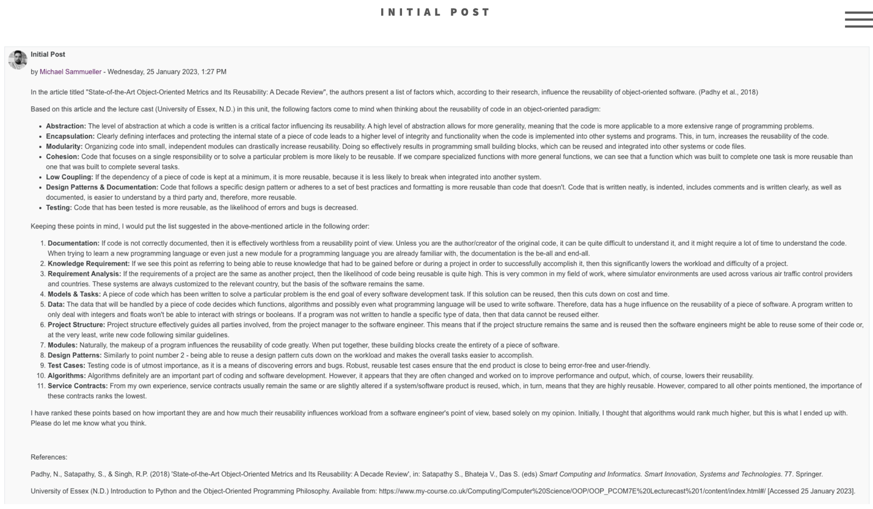

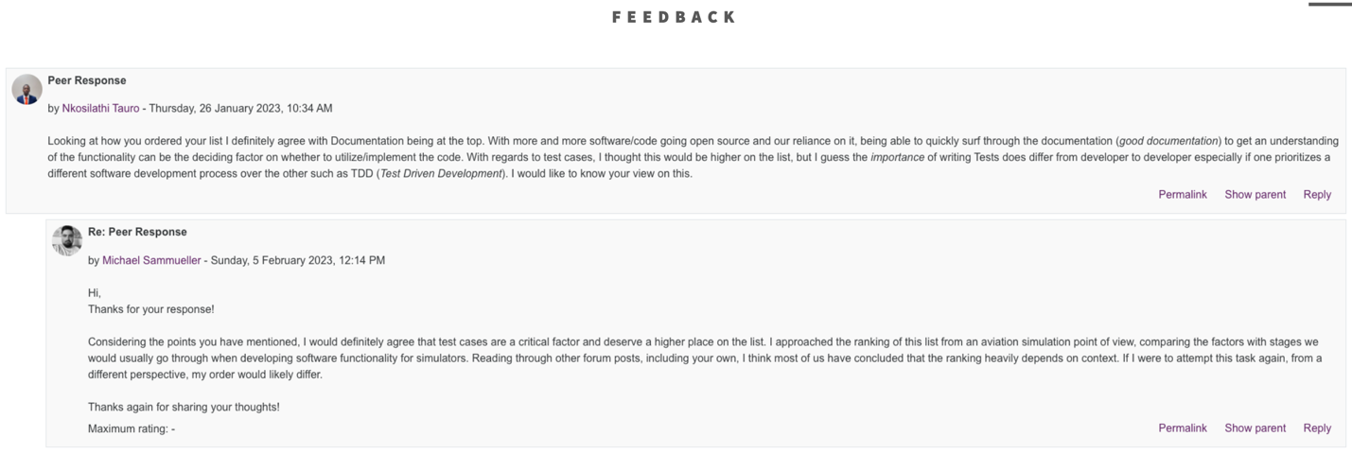

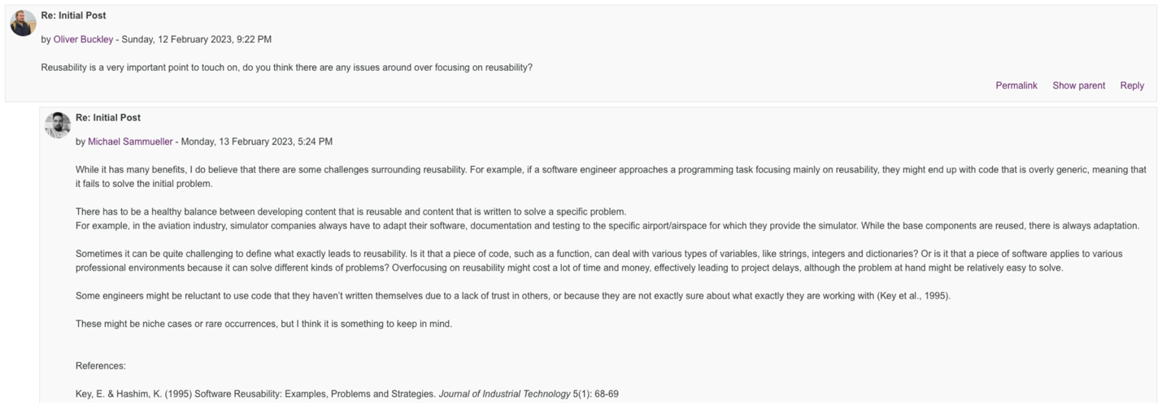

Because I consider participating in these group activities essential, I have chosen each of them as one of my unit artefacts in my ePortfolio.

**Skills and Knowledge**

As discussed in my ePortfolio, I truly learned a lot in this module. For instance, before studying this module's contents, I was unaware of how to automate testing correctly, use the assert statement, raise custom errors, use linters to check code and use UML to design systems. Furthermore, learning about the object-oriented paradigm opened doors for me to improve my personal projects. As evidenced throughout my portfolio (see example below), I used this chance to experiment with my own code and projects, as I find that this significantly improves my understanding of coding principles (see screenshot below).

­­­­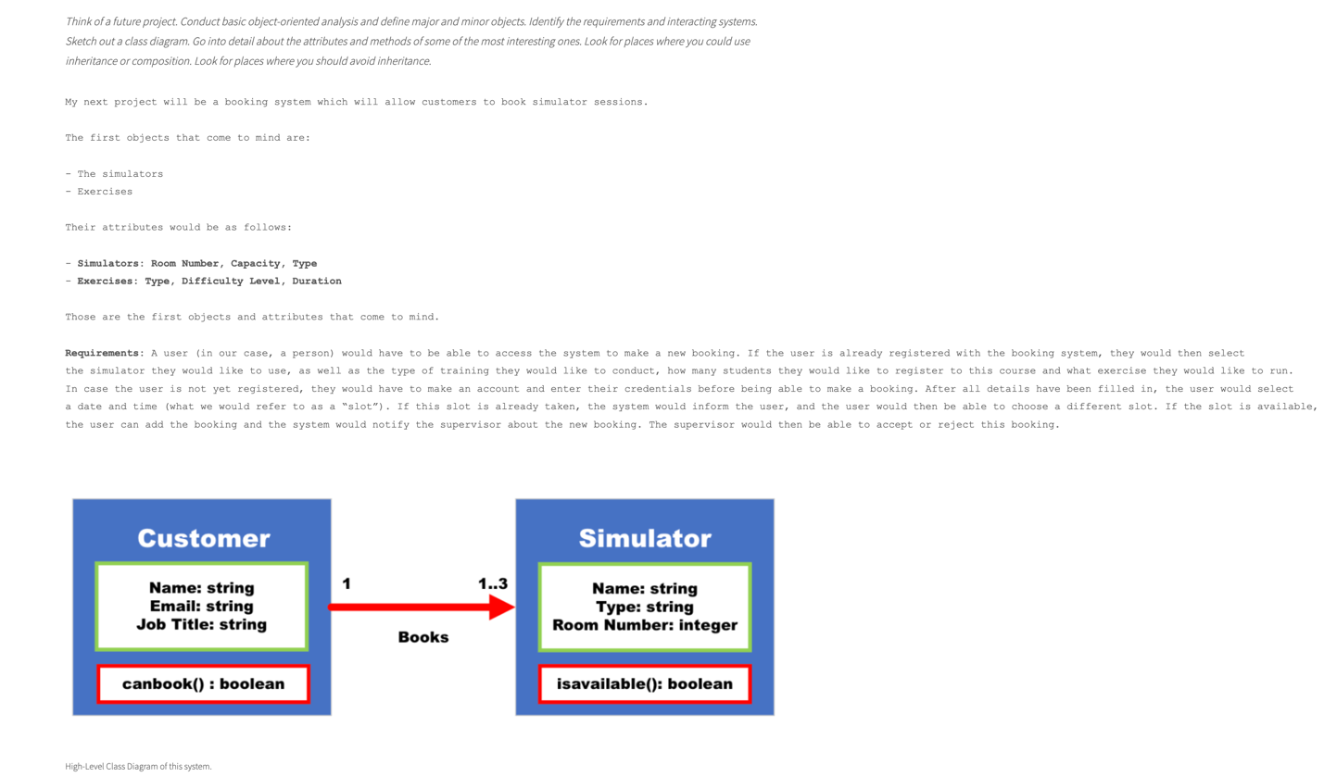

**Conclusion**

All in all, I am satisfied with my approach to this module. I was able to apply my experience from the last module and improve on my shortcomings. Moving forward, I hope I can throttle my tendency to overthink and limit the scope of my designs to avoid running into dead-ends or problems with deadlines. Although this has not happened yet, it would be best to change these habits sooner rather than later.

**References**

Biwer, F., Oude Egbrink, M. G. A., Aalten, P. & De Bruin, A. B. H. (2020) Fostering Effective Learning Strategies in Higher Education – A Mixed-Methods Study. *Journal of Applied Research in Memory and Cognition* 9(2): 186-203